Conference Schedule

August 3
1:00 Conference registration opens
2:00 pm Mass
With music by Chant Philadelphia
led by James Griffin

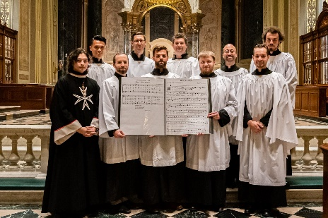
Chant Philadelphia is associated with the Personal Ordinariate of St. Peter, which ordains priests who have converted from the Anglican and Episcopal Churches. This Mass will use their approved rite

Session 1: Personal Influence
4:00 David Delio: Remembering John Ford
Peter J. Gruber, C.O: Newman and Personal Influence in the Oratorian Priesthood

5:00 Supper
6:30 Evensong with Chant Philadelphia
7:30 Beer and Wine Social

August 4
8 a.m. Morning Prayer
8:30 Breakfast

Session 2: Educational Conflicts
9:30 a.m. Rev. Prof. Stephen Morgan: Has Hawkins won the day?
Scott Goins: Newman, Locke and Personalism in Education

10:30-11:00 Break

Session 3: Newman and Law
11:00 Stefanus Hendrianto, S.J., Ph.D: St. John Henry Newman’s Constitutional Thought: On God, State, and Constitution
Dr. David P. Long, S.T.L., M.Phil., J.C.D. : John Henry Newman, Canon Lawyer?

12-1:00 Lunch

Session 4: Counsel and Conversion
1:00 Barabara Wyman: Counselor to Conflicted Christians Seeking Conversion to Catholicism: The Case of Kate Froude
Rev. Jason Catania: Newman and the Conversion of The Most Reverend Alfred Curtis

Session 5: Ecumenism and Anglicanism
2:00 Joseph Roberts: Anglican Cultural and Ecumenical Identity
Fr. Prof. Przemyslaw Kantyka : Search for truth as the basic paradigm of Newman's theological thought and Anglican-Roman Catholic ecumenical dialogue

3-3:30 Break

Session 6: Conscience and God
3:30 Fr. Paweł Robert Surowiec, S.T.L., 'Myself and my Creator' – the primacy of God and its relevance to ecumenical dialogue
Robert James Lisowski, C.S.C.: Silences and Subtle Voices: Newman and Heidegger on Conscience.

5:00 Mass

6:30 Banquet

7:30 Keynote: Michael Pakaluk: Newman and Philosophy
Followed by Social Hour
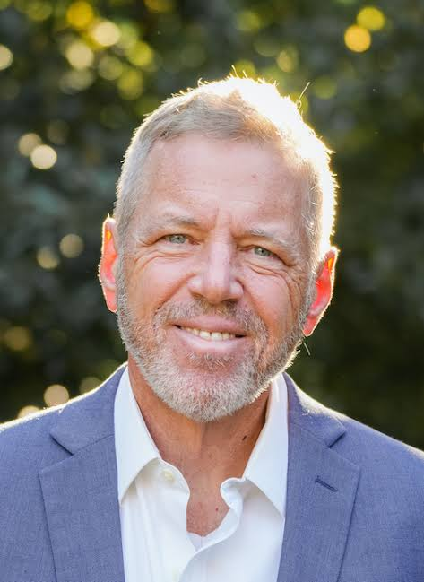

Keynote Michael Pakaluk , Ph.D. Harvard, teaches at the Catholic University of America. Expert in Thomas Aquinas, Aristotle and Newman, he like Newman took Hume as a sparring partner. He studies ethics and the philosophy of friendship. He published bestselling The Appalling Strangeness of the Mercy of God. (Ignatius Press ,2011)

August 5
8am Morning Prayer
8:30 Breakfast

Session 7: Humanity and Spirituality
9:30 Rev Peter Conley, MPhil, STL: Detecting Newman’s Humanity: Discovering fresh clues to his Pastoral effectiveness (via Zoom)
Fr. Joseph Pearce: John Henry Newman: A Model of Integrity, Holiness and Faithfulness

Session 8: Saints as Mentors
10:30 Bernadette Waterman Ward: Newman’s Model Mentor, St. Cyprian
Matthew McKenna: “Newman on Devotion to the Saints”

11:30 Closing Mass
12:30 Lunch and Farewells

Remembering our beloved mentor Fr. John Ford, who was among the founders of the Newman Association, we welcome both old friends and newcomers to a conference celebrating St John Henry Newman, whose life and work Fr. John studied for more than half a century. He mentored many young scholars and lived his pastoral commitment deeply, especially with the Spanish-speaking community in the Washington, DC area.
John’s talent for friendship, like Newman’s own, calls us to meet in person for intellectual and spiritual fellowship.
We thank the Catholic University of America, and especially Vice Provost David P. Long, for generous support.
We also thank James Griffin, whose enthusiasm for liturgical music has allowed us to enjoy the fellowship of converted Anglicans in the Personal Ordinariate of St. Peter. Come and celebrate with us!

Registration for 2023 Newman Conference (Check one)
Talks with Housing and Meals:
____ $250 Association members
____ $270 nonmembers
Talks only with lunch (no housing)
_____ $50
____ Students at Catholic University of America and Christendom College free with student ID and paid student discount membership of $20
___ Zoom participation free with membership

TOTAL: ________________

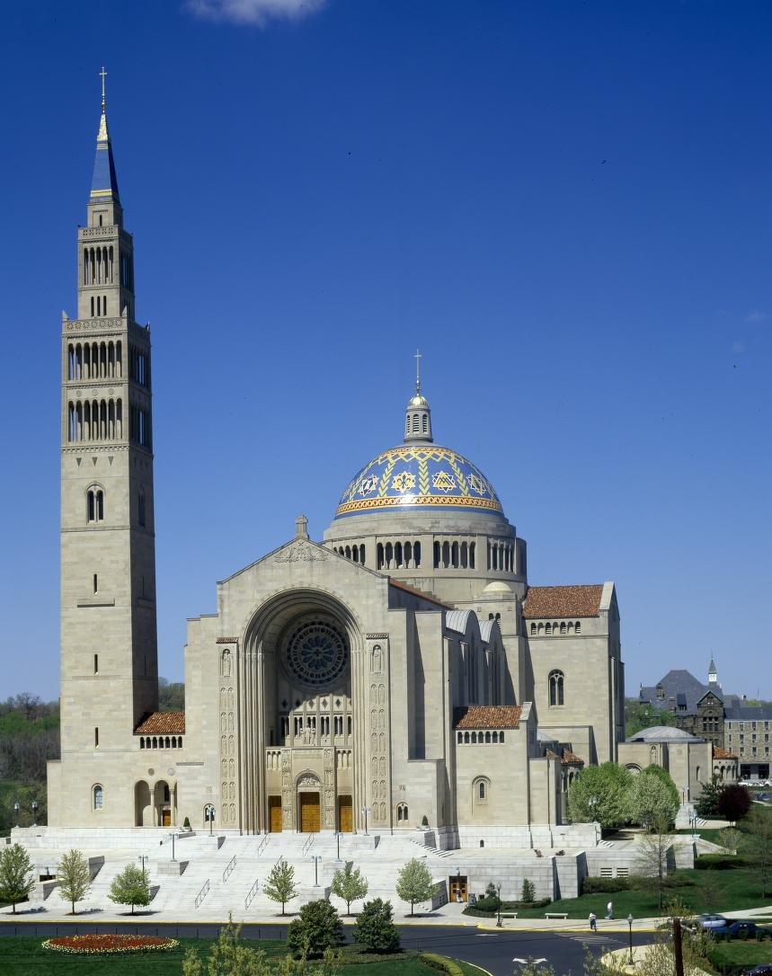
Basilica of the Immaculate Conception

Register online at: https://sjhnaa.org
Using Paypal or credit card or if you wish to pay by check mail to:
Saint John Henry Newman Association
c/o Office of the Provost
Seton Hall University
400 South Orange Avenue
South Orange, New Jersey 07079

****************************
Make checks payable to Saint John Henry Newman Association of America

Catholic University of America and
the St John Henry Newman Association

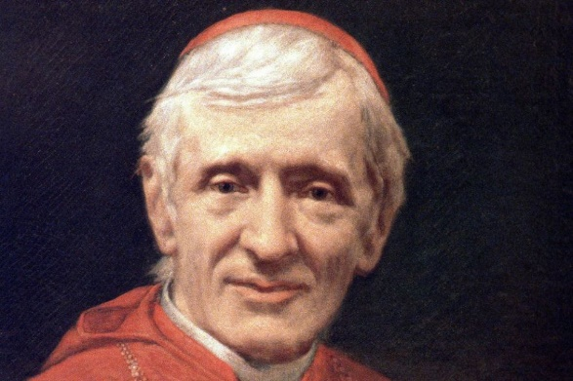
Invite you to register for

Integrity, Authenticity, Mentorship:

St. John Henry Newman
In honor of Fr. John Ford
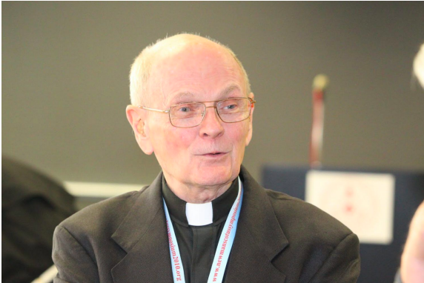
August 3-5, 2023

